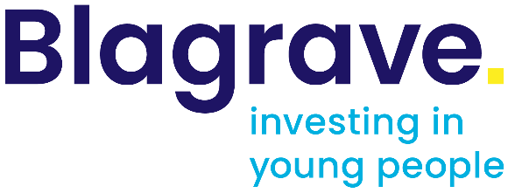

Terms and Conditions of Funding
DO NOT SAVE OVER THIS TEMPLATE
Organisation: XXXX

Grant amount: XXXX pa X X years

Grant period: XXXX starting from the date that you sign these Terms and Conditions, below.

Purpose: an unrestricted grant, which may be used to cover the core costs of your organisation, or restricted to …..

Conditions: This grant must be taken up within one year of approval. Multi-year funding is subject to:
- Availability of funding
- Satisfactory annual monitoring and review of performance.
- Add any further conditions here

- You agree to use the funding for the purpose described above by the end of the grant period.

- Regular updates on the progress and outcomes of your work must be provided, at least annually. The Blagrave Trust expects you to act in an open and honest manner with these reports.

- Organisations must keep proper accounts of income and expenditure. A full financial report, independently audited or examined, for the year in which the grant is used, must be made available as well as an account of how the grant has been spent.

- The amount is inclusive of VAT, if applicable.

- The Trust will monitor your use of the Grant or your activities, may ask to visit you, and may ask you to come to its offices to report on your work. You agree that you will reasonably assist the Trust with such requests.

- In addition, as a recipient of a grant from the Trust, you agree to:

  - Inform the Trust immediately of any significant change in the structure, staffing, management or governance arrangements of your organisation. You shall notify the Trust if you become aware that any key staff may step down or leave the organisation which will affect its overall management.

  - Notify the Trust in writing if you believe that you may make any significant and substantive change to your organisational delivery, if you are unable to meet your debts as they fall due (or if you anticipate any other similar pre-insolvency or administration event) or if you anticipate any other significant changes to your organisation.

  - Notify the Trust in writing of any circumstances that arise that significantly affect the use of the grant. Permission to change the terms of the grant in these circumstances will be solely at the discretion of the Trust.

  - Return to the Trust any grant, or part thereof, not used.

  - If the grant is to fund or part fund equipment or assets, you will not sell or dispose of the assets during the grant’s lifetime or within a reasonable period after the grant ceases without first receiving the written permission of the Trust.

  - Inform the Trust of any financial or operational difficulties or irregularities that arise that could damage the reputation of your organisation, partner agencies or your parent organisation.

  - Uphold the highest standards of child protection and safeguarding and inform the Trust of any substantive changes to your safeguarding policy or if a serious safeguarding issue should arise that could damage the reputation of your organisation.

  - For the duration of this agreement you shall not breach any laws or do or fail to do any act which might reasonably damage the Trust’s reputation.

- Information regarding the organisation and the grant received will be published by the Trust on its website and the Trust reserves the right to use the information in any other printed or on-line information it produces

- Whilst our intention is to pay the grant in full, The Trust may hold back a grant or ask for repayment in whole or part in the following circumstances:

  - If you are in material breach of any or all of the terms of this agreement

8.2 If any member of the governing body, staff or volunteers act dishonestly or negligently or provides false or misleading information at any stage in the relationship.

  - If the organisation closes down, goes into administration, receivership or liquidation.

- The Blagrave Trust accepts no liability for any consequences that may arise from your use of the grant. You shall indemnify the Trust from all claims, demands, actions, costs, expenses, losses, damages and all other liabilities arising.

I am authorised to acknowledge receipt of the grant offer from The Blagrave Trust. On behalf of this organisation I accept the Terms and Conditions stated and any additional conditions included in the grant offer letter.

 | For the organisation | For the Blagrave Trust
Name
Position
Signature
Date

